 | Journal of South Asian Logistics and Transport  Volume 4 Issue 1 March 2024  JSALT #########  DOI:

TITLE
A.B. Perera ª, Initials. Surname ^{b} and Initials. Surname ^{b} *
ª Affiliation 1 (dept. name of organization, organization, city, country)
^{b} Affiliation 2 (dept. name of organization, organization, city, country)
* Correspondence should be addressed to email@email.com

ABSTRACT
Your abstract should begin here. The abstract should be a single paragraph of about 200 words maximum. For research articles, abstracts should give a pertinent overview of the work. We strongly encourage authors to use the following style of structured abstracts, but without headings: (1) Background: Place the question addressed in a broad context and highlight the purpose of the study; (2) Methods: briefly describe the main methods or treatments applied; (3) Results: summarize the article’s main findings; (4) Conclusions: indicate the main conclusions or interpretations. The abstract should be an objective representation of the article and it must not contain results that are not presented and substantiated in the main text and should not exaggerate the main conclusions. All submissions are governed by the JSALT Editorial Policies. Further information is available in the JSALT Guidelines for Manuscript Submissions.
Keywords: Keyword 1, Keyword 2, Keyword 3, (List two to five keywords specific to the article yet reasonably common within the subject discipline. Undefined abbreviations or acronyms should be avoided in the keywords. Editorial Board reserves the right to replace keywords if necessary )

*Your abstract and keywords should not exceed the first page (this page) of your manuscript.

Introduction (HEADING 1)
The first paragraph of your article should begin here. The template is used to format your paper and style the text. All margins, column widths, line spaces, and text fonts are prescribed; please do not alter them.
Articles must be written in standard UK English. Proper grammar is a requirement for publication in JSALT. Any articles submitted with poor grammar will be immediately rejected. All articles must be prepared using this template and submitted as a Microsoft Word document.
JSALT does not have a page limit for articles. However, it is recommended to keep the page count under 25 B5 pages or 6,000 words for ease of readability. Longer articles may result in longer peer review times. Additional content can be added as supplementary material.
All third-party-owned materials used have been identified with appropriate credit lines, and permission has been obtained from the copyright holder for all formats of the journal. Authors acknowledge their responsibility to gain all permissions before submission.
Author lists should be carefully considered before submission. All contributing authors qualify as authors, as defined in the authorship guidelines, and have permitted to be listed on the submitted paper. (Changes to the author list during the post-acceptance are not allowed.)
References should be numbered in order of appearance and indicated by a numeral or numerals in square brackets—e.g., [1] or [2,3], or [4–6]. See the end of the document for further details on references. Define abbreviations and acronyms the first time they are used in the text, even after they have been defined in the abstract.

EASE OF USE (HEADING 1)
You can divide the subsections of your articles using the below formats. If there are two or more sub-topics, the next level head (Heading Style) should be used and, conversely, if there are not at least two sub-topics, then no subheads should be introduced.

Subsection 1 – Bullets and Numbers (Heading 2)
Write the content related to Subsection 1.

Bulleted lists look like this (Heading)
- First bullet
- Second bullet
- Third bullet

Numbered lists look like this (Heading)
- First item
- Second item
- Third item
The text continues here.

Subsection 2 - Figures and Tables (Heading 2)
All figures and tables should be cited in the main text as Figure 1, Table 1, etc. Figures and Tables should be placed in the main text near the first time they are cited. Figures should be fitted into the body area in portrait orientation. Photographs should be preferably scanned with a resolution of 220 dpi in .jpg or .tif format and sized before placement in the manuscript. Each figure should be sequentially numbered, and the caption should be located below the Figure. All figures should be in sharply contrasting colours so that they can easily be legible even in black and white prints. Sans-serif fonts (Arial or similar) should be used in figures.
Tables should present useful information and not merely duplicate what is in the text. Tables should be numbered. The caption should be clear enough to represent what is presented in the table and should be located above the Table. Please supply editable files ideally in Excel (Tables should not be put in the form of a picture).
Figure 2 and Figure 3 show another example of including figures. (You could use this format to include figures only if the letters included in both figures are legible). Authors can reduce the font size used in a table body if the table has a large amount of information but it should not be less than size 10.
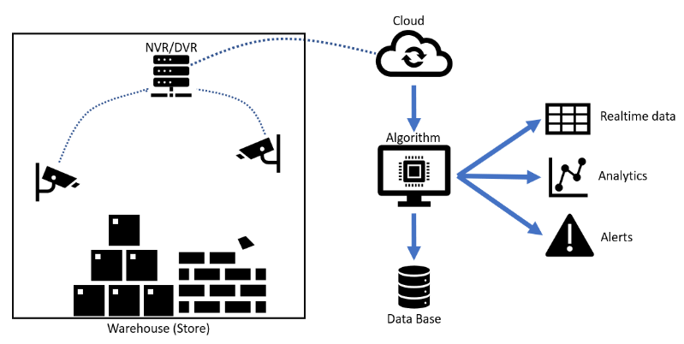
Figure 1: This is a figure. Please follow the same
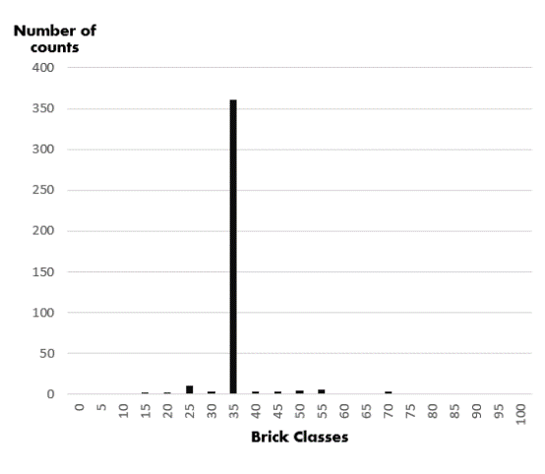 | 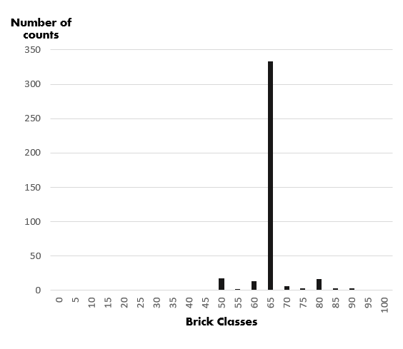
Figure 2: This is a figure. Please follow the same formatting | Figure 3: This is a figure. Please follow the same formatting

Table 1: This is a table. Please follow the same formatting. You can add or remove columns and rows based on your table content
Parameter | Output type | Indication | Evaluation Thresholds
Loss | Graph | Should be concentrated closer to 0 | -
Accuracy | Graph | It should be concentrated closer to 100% or 1 | -
Intersection over Union (IoU) | Graph | It should be concentrated closer to 1 | -
Mean Average Precision (MAP) | Ratio/Percentage | Should be closer to 0.01 or 1% but practically it goes around 30% to 50% | Less than 50%
High Confidence False Positives | Ratio/Percentage | Should be closer to 0.01 or 1% | Less than 5%
Root Mean Squared Error (RMSE) | Value | It should be closer to 0 and more significant than MSE but should be closer to MSE | Less than 2
The text continues here.

Equations
Equations should be indented and separated from the text. All equations should be numbered and cited as follows. Be sure that the symbols in your equation have been defined before or immediately following the equation. Use “(1)”, not “Eq. (1)” or “equation (1)”, except at the beginning of a sentence: “Equation (1) is . . .”.
$MSE=\frac{1}{n}\sum_{i=1}^{n}{{(Y_{i}-{\hat{Y}}_{i})}^{2}}$ (1)
where,
${\hat{Y}}_{i}$ : predicted value
$Y_{i}$ : actual value
n: the size of the data set

Footnotes
Number footnotes separately in superscripts. Place the actual footnote at the bottom of the page in which it was cited. Do not put footnotes in the abstract or reference list. Use letters for table footnotes.

Heading 2
The text continues here.

Heading 2
The text continues here.

HEADING 1

Heading 2
The text continues here.

Heading 2
The text continues here.

Heading 2
The text continues here.

Heading 2
The text continues here.

Heading 2
The text continues here.

Heading 2
The text continues here.

HEADING 1
The text continues here.

HEADING 1

REFERENCES
JSALT uses the standard IEEE referencing style in all articles. (https://ieeeauthorcenter.ieee.org/wp-content/uploads/IEEE-Reference-Guide.pdf) References must be numbered in order of appearance in the text (including citations in tables and legends) and listed individually at the end of the manuscript. We recommend preparing the references with a bibliography software package, such as EndNote and Mendeley Reference Manager to avoid typing mistakes and duplicated references. Following are some common referencing style examples:
Journal Paper
V. Weerapura, R. Sugathadasa, M. M. De Silva, I. Nielsen, and A. Thibbotuwawa, “Feasibility of Digital Twins to Manage the Operational Risks in the Production of a Ready-Mix Concrete Plant,” Buildings, vol. 13, no. 2, 2023, doi: 10.3390/buildings13020447
Conference Paper
M. Gamlath, K. G. A. S. Waidyasekara, and S. Pandithawatta, “Feasibility of Robotic Technology for the Advancement of Construction Industry in Sri Lanka,” MERCon 2020 - 6th Int. Multidiscip. Moratuwa Eng. Res. Conf. Proc., pp. 1–11, 2020, doi: 10.1109/MERCon50084.2020.9185384

APPENDICES

Appendix A:

Appendix B:

Revised 3rd April 2024

